March 14, 2024, Board Agenda
Halt Violence
2360 W. Broad St
Columbus, Ohio
6:30 pm – 7:45 pm

Board Members:

Thell Robinson III- President/CEO
Jonathan Olivito - Chair
Todd Kaufman- Vice Chair
Curtis Hairston- Treasure/ Secretary

Old News:

Halt Violence awaits a $50,000 grant in with Pepsico Foundation.

New Business:

Halt Violence performed 57 conflict mediations in 2023. Thanks to our team, we were able to squash 46 beef that stopped murders, shootings and fights among black youth, black teens, and black adults. However, we had 11 that we couldn't prevent. With our help, disputes ceased among individuals, squads, gangs and even families! Our Street Mentors, through tireless efforts, are still pursuing the beef that is still on going. These disputes are not simply forgotten.
Halt Violence enrolled 175 participants. 70% males, 30% females & 19% of the clients were under 18 years old seeking mentorship or trauma counseling. 5% of our clients were white, 3% other and 92% black.
- 37% of our clients received trauma counseling.
- 38% of our clients received mentorship.
- 22% of our clients gained employment.

Thus far, Halt Violence has raised $15,325.

Halt Violence has 7 beefs squashed and 4 ongoing.

Currently, Halt Violence has 37 clients (15 youth).

The Rhema Family donated $2,000 to further the campaign for Squashing Beef.

Halt Violence submitted a grant to the Office of Criminal Justice (ARPA Governor’s Office) for $300,000. This would be from March 1, 2024, to June 2026 if approved.

Halt Violence has a capacity of eight staff. One LSW, 4 Full-time Street Mentors, 1 part-time Mentor, 1 Case manager.

The Columbus Office of Violence Prevention requested that Halt Violence attend February 21, 2024, and Thursday, February 22, 2024, from 9 a.m. until 4 p.m. EACH DAY for their 2024 Violence Prevention Convening for city intervention and interrupter staff.

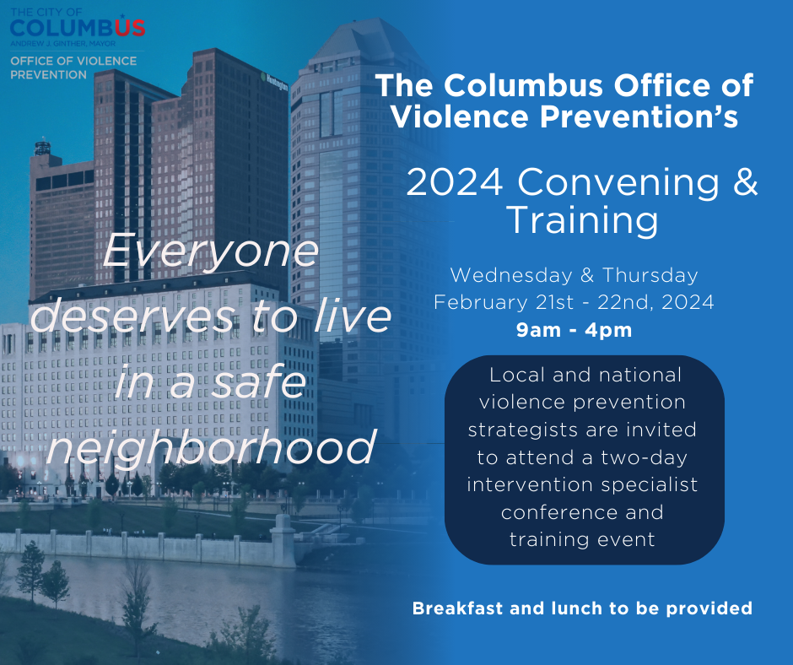

The Director was made aware that Halt Violence doesn’t work with the police. Halt Violence was under the impression that after our 10-minute presentation, the City of Columbus would be open to our model. Especially, since we had more impact than some of our competitors that were in the room.

Unfortunately, Halt Violence learned that the Baltimore model that Columbus is following, “This can’t work without the police.” According to their methods. Halt Violence will not attempt to cultivate a relationship because they won’t accept our model.

Halt Violence has 990 and Financial Compilation done. See attachment.

Franklin County Children Services attended our contract an extra year for trauma counseling and mentorship.

Halt Violence with the partnership of Rhema, we hosted pizza awareness events with youth at the Hilltop Library, Whitehall Library, Franklinton Prep High School, Franklinton library and Groveport library. At each location, we served 50 to 60 youth pertaining to our services. In addition, we have Shephard library March 7, 2024, YMCA Family Shelter March 14, 2024, and Westland library on March 27th.

Halt Violence submitted a $2,000 sponsorship to YAC Youth Advisory Council for Halt Violence Mental Health Day at our west location April 25, 2024, from 5:30 pm to 8:30 pm. Mental health is a layer to gun violence that the black community doesn’t discuss because no one wants to be labeled crazy. Therefore, we will take the lead on this topic to bring awareness to cease some of the gun violence.

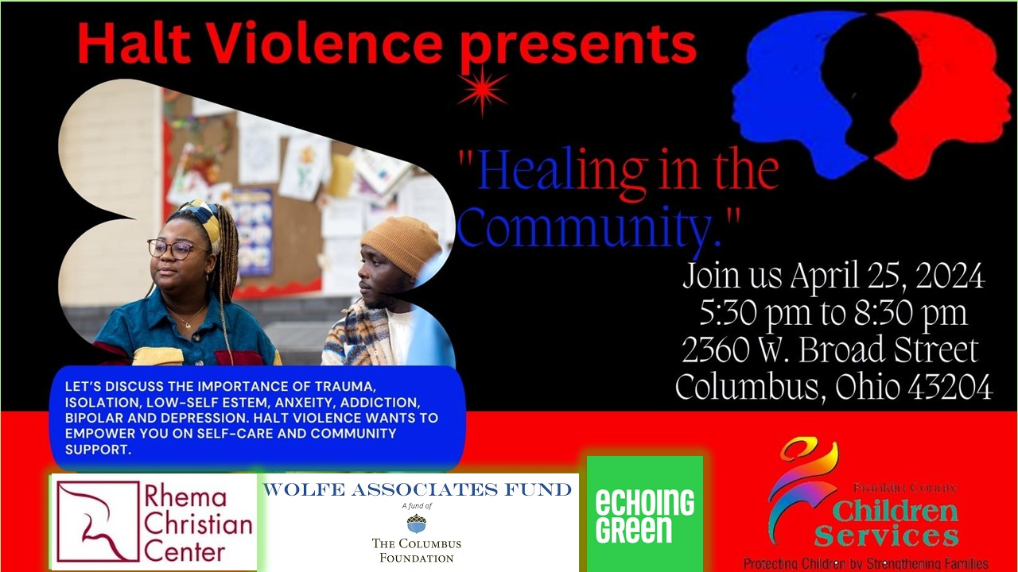

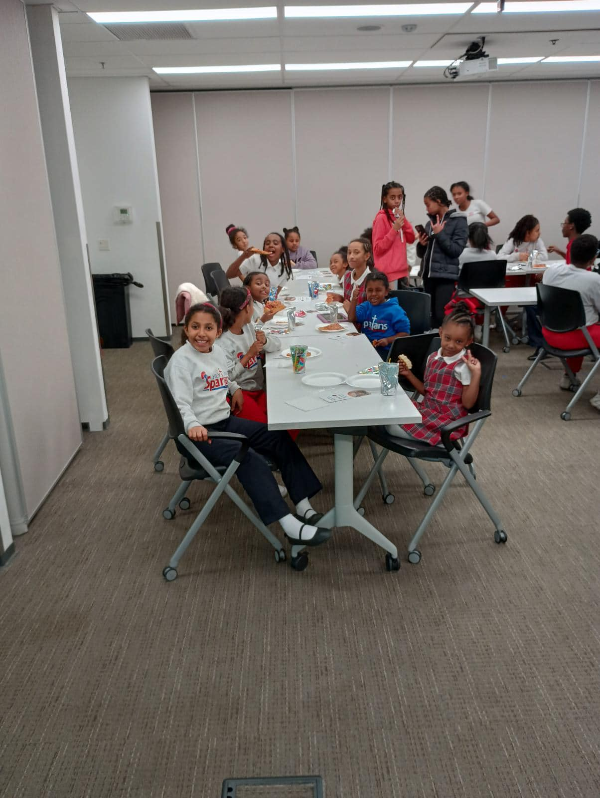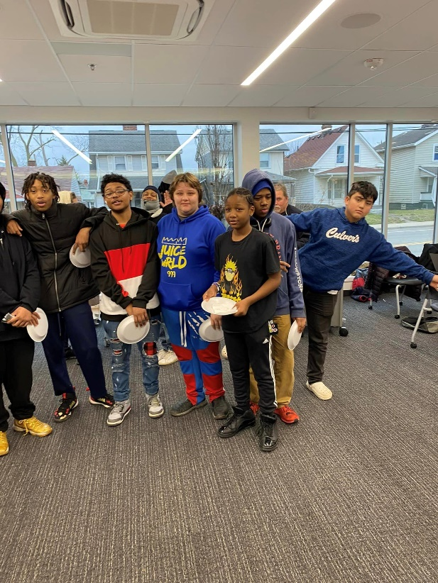

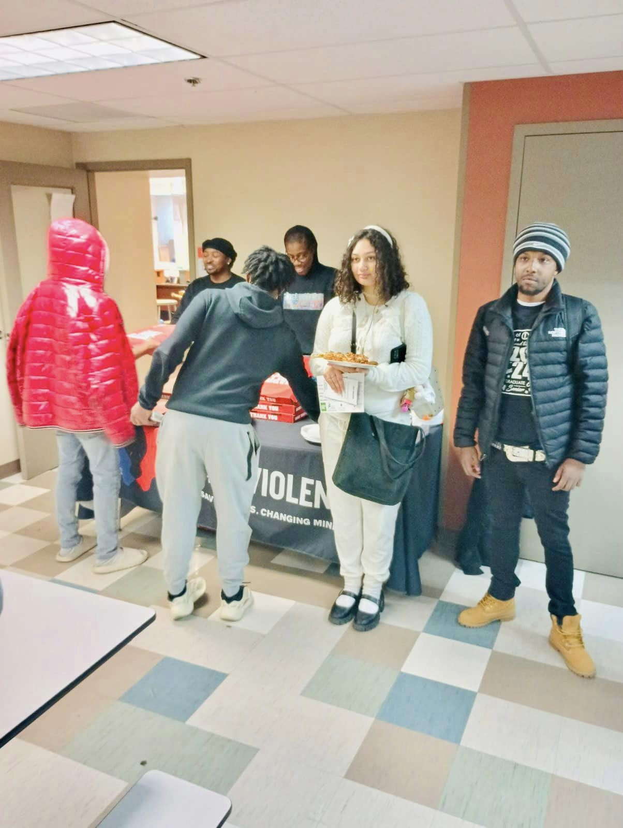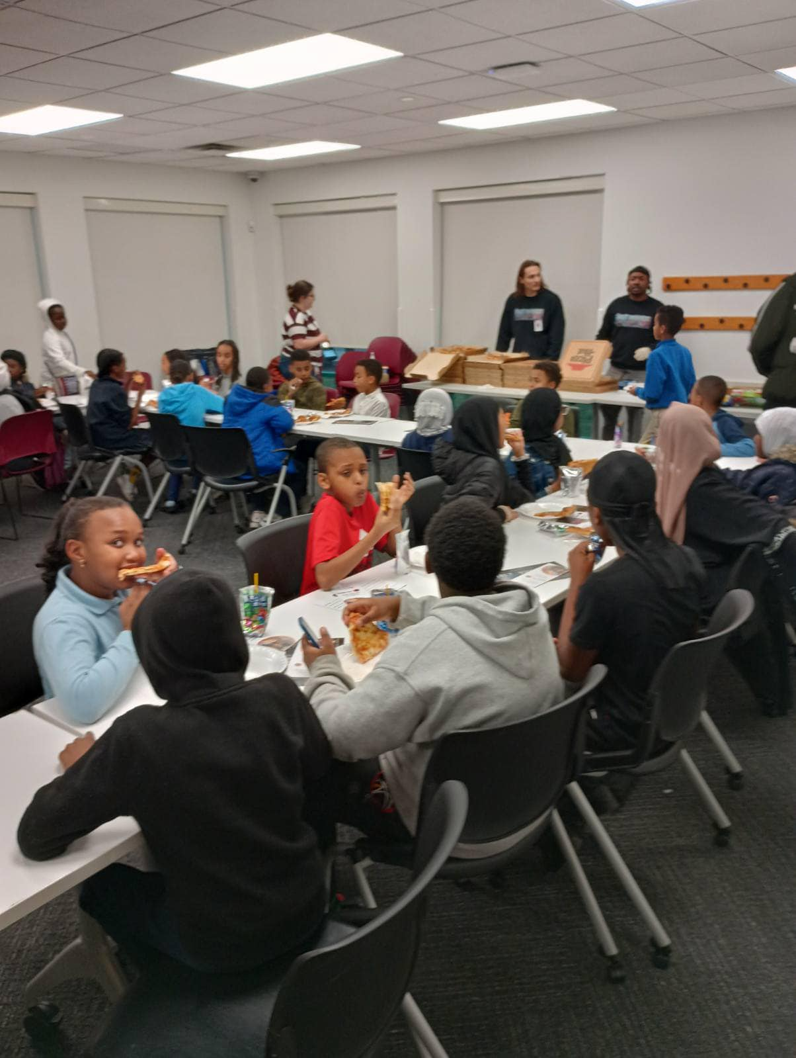

The Franklin County Board of Commissioners invited Halt Violence to a grant opportunity that is due March 27, 2024. I gave the draft to Jonathan. This would be $300,000.

Examples of Beefs:

North Side
43219
Submitter
Ein Johnson
Submission Date
Jan 25, 2024, 9:30 AM
Level of Beef.
Argument
Fight
What is the reason for the beef?
The reason for the beef was because one teen said the other used to be his dude then he started saying things about him to his other friends saying that he a snitch and things like that.
What is the outcome of the beef?
The outcome of the beef was that they fought it out and before it escalated one of the parents called me. I came and talked to both parties and they tried to talk it out for a while and get to the bottom of the he says she say. But they just let it be and both went their separate ways for now and said it's over.
Date
Jan 24, 2024
Is the beef squashed or ongoing?
Yes
What type of Beef?
Neighborhood Beef
What neighborhood?
North Side
What zip code?
43219
What method was the beef outcome performed?
In person
How many individuals were involved?
2

West
43204
Submission Date
Jan 22, 2024, 1:20 PM
Level of Beef.
Argument
Fight
What is the reason for the beef?
Boy1 and Boy2 go to the same church and Boy2 smacked Boy1 little brother and this is the first time Boy2 bullied Boy1 little brother... Boy1 and Boy2 seen each other at the hilltop Library and had words then was about to fight.
What is the outcome of the beef?
I talked to Boy1 and his friends about the situation Boy1 is saying he is willing to sit down with me and Boy2 to squash the beef whenever Boy2 was available.
Date
Jan 19, 2024
Is the beef squashed or ongoing?
Yes
What type of Beef?
Individual Beef
What neighborhood?
West
What zip code?
43204
What method was the beef outcome performed?
In person
One party of the Beef
How many individuals were involved?
2
Submitter
Matt Williams

Next board meeting is June 13, 2024.

