June 22, 2023, Board Agenda
Halt Violence
2360 W. Broad Street
Columbus, Ohio 43204
6:30 pm to 7:30 pm

Board Members: Thell Robinson III- President/CEO
Jonathan Olivito- Chair
Todd Kaufman- Vice Chair
Curtis Hairston Jr- Treasurer/ Secretary

Old News:

Halt Violence received $282, 450 from the Governors Violence reduction grant that Thell submitted for 2 years. With that, Halt Violence will hire 2 full time Street Mentors, a part time Street Mentor and a LSW case manager part time.

Halt Violence still awaits Ms. Owens from the Department of Youth Services for an update on receiving referrals for youth through the juvenile courts.

Halt Violence awaits a $270,000 grant in with My Brother’s Keeper through the City of Columbus.

Halt Violence placed a $50,000 grant in with Pepsico Foundation

New Business:

Curtis renewal as a board member because it expires this month.

Halt Violence stands correct. Thell made $40.38 per hour in 2022.

Halt Violence has squashed 20 beefs that could have resulted in a fight, shooting or murder. 7 beefs are still ongoing and 1 is not known.

Halt Violence has 33 clients, 13 of them being youth.

Thus far this year, Halt Violence has raised $120,904.92.

Let’s decide on Thell’s increase of his hourly wage.

Halt Violence submitted $100,000 Racial Equity grant with Echoing Green and received it.

Cut masters Barbershop, our community partner donated 8 chairs that are used for both locations.

Halt Violence placed a building permit with zoning to learn the maximum number of people we can have in our west location.

Level of Beef.
Argument
What is the reason for the beef?
Halt Violence had to intervene in a verbal altercation that was about to be physical between two members of the community meeting due to prior issues in the past meetings.
What is the outcome of the beef?
The beef got squash due to the team effort of a community member and resident in the violent community.
Date
Jun 1, 2023
Is the beef squashed or ongoing?
Yes
What type of Beef?
Individual Beef
What neighborhood?
west
What zip code?
43228
What method was the beef outcome performed?
In person

Level of Beef.
Argument
What is the reason for the beef?
Halt Violence spoke with #12 dad about his behavior. He has been getting into it with the police lately. He has two incidents with police that can be deadly if #12 doesn't change his attitude.
What is the outcome of the beef?
Halt Violence offered trauma counseling to #12. The dad will see if #12 is on board to prevent the ultimate interaction with #12 and the police.
Date
Jun 1, 2023
Is the beef squashed or ongoing?
Ongoing
What type of Beef?
Individual Beef
What neighborhood?
Whitehall
What zip code?
43213
What method was the beef outcome performed?
In person
One party of the Beef
With dad of #12

Data from enrollment since 2014… below.
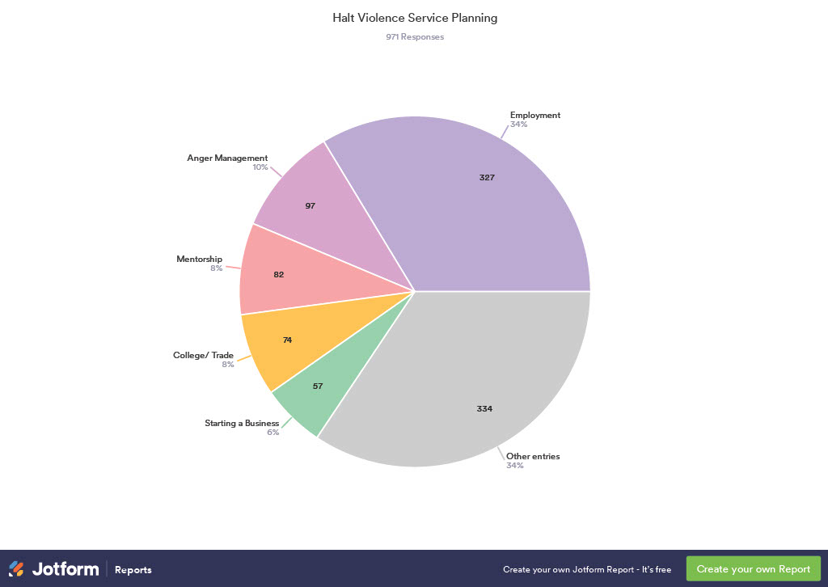

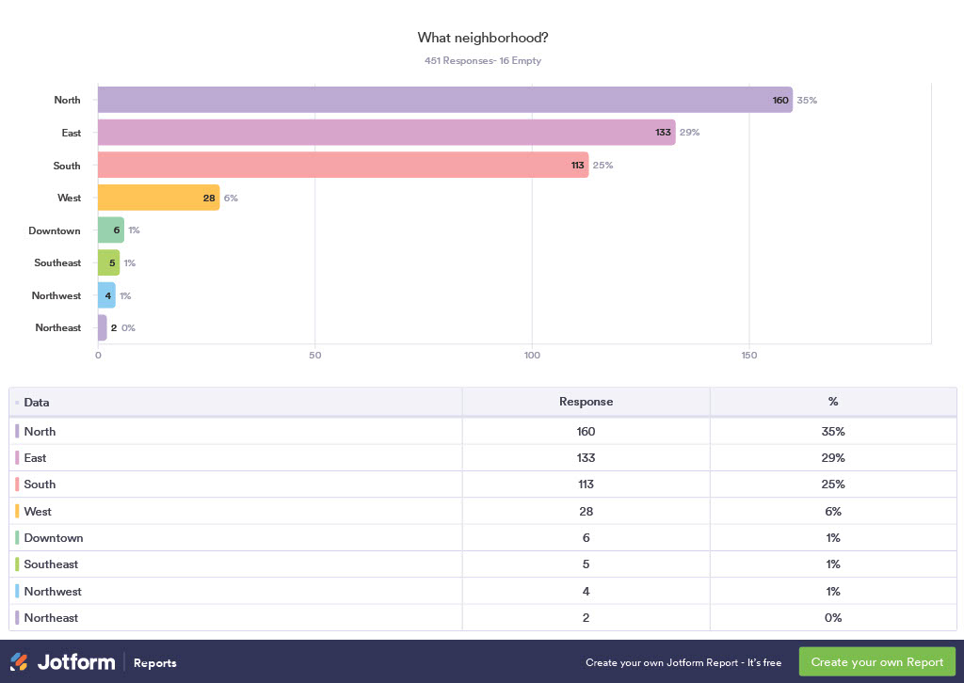

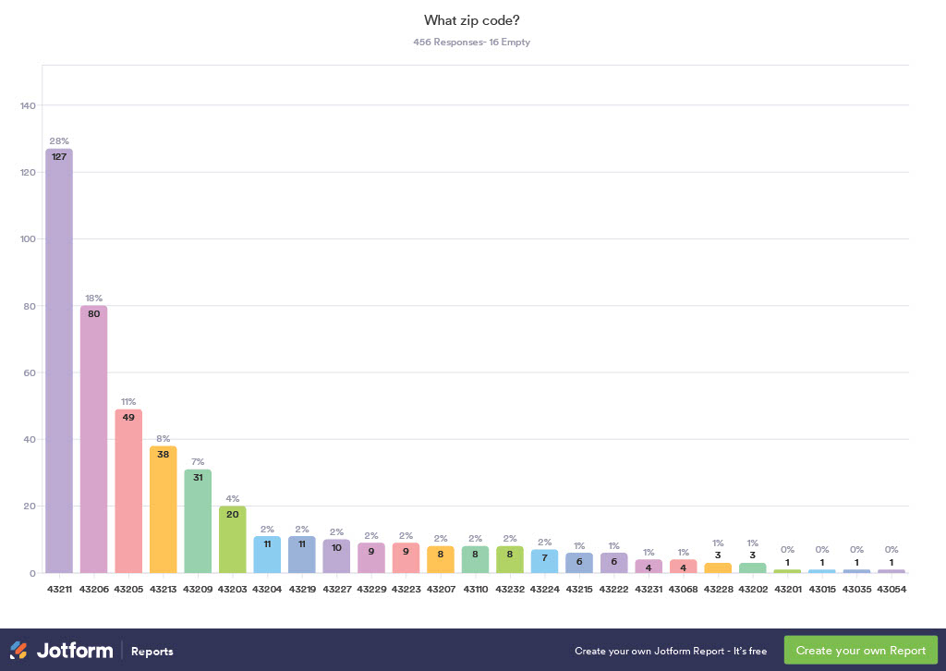

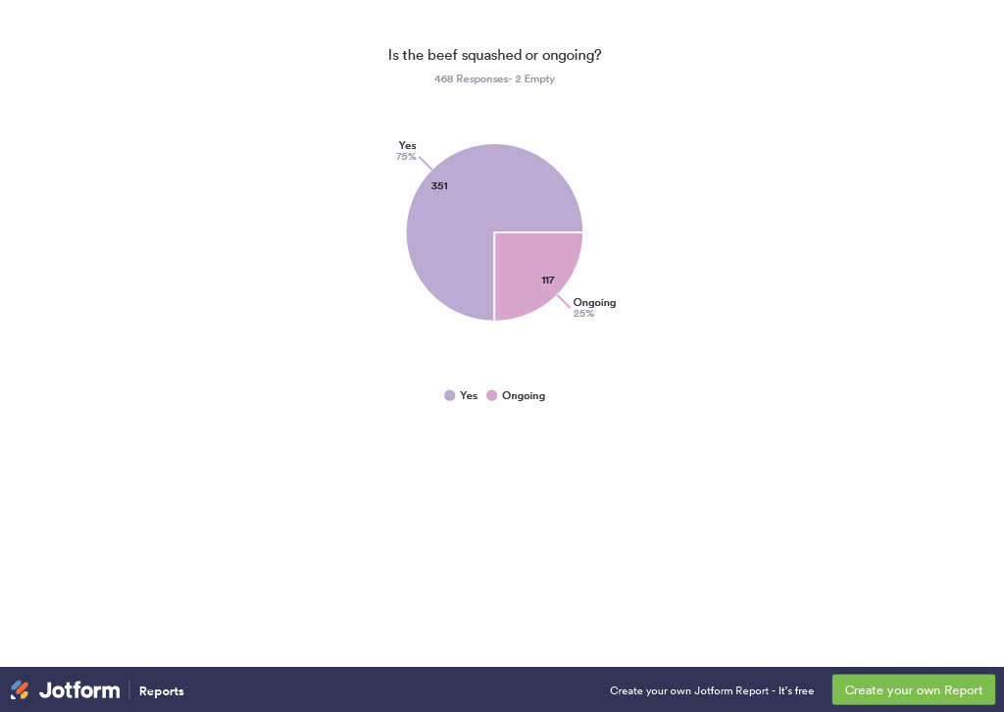

Next board meeting September 14, 2023. If someone has a conflict, please let us know now and not the day before.

